Your name: ________________________________________________________

## Week 14 Review

Please complete the following problems showing all work. You will be graded on mathematical accuracy and showing ALL steps. Each question is worth 5 points.

1. For the one-to-one function $f\left(x\right)=3x+8$, find a formula for the inverse function $f^{-1}\left(x\right).$
2. Solve: $\log_{2}{(4x-8)}=3$
3. Graph the exponential function $f\left(x\right)=2^{x}-4$. Find and label the $y$-intercept and the asymptote. In addition, label coordinates of 2 other points on the graph.

Y-intercept: $( , )$

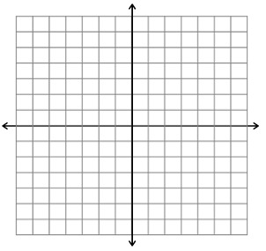

Equation of asymptote:______________

Additional points: $( , ) , ( , )$